Nombre: ____________________________ Bloque: ________ Fecha: _______________________
Español 1 - Unidad 6 – La cultura – Dominican Republic
Instrucciones: Fill out the following notes sheet based on the cultural activities online. This follows the online activity in order by section. Make sure to hold on to this paper to study, as this information will be part of the exam! This can also be used as a backup should you lose internet connection while working.

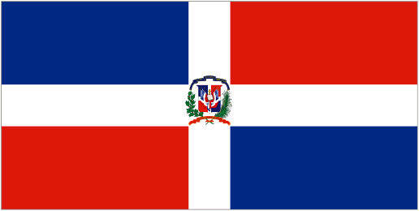
Información general:
- The capital of the Dominican Republic: _________________________
- Languages spoken: _______________________________________

- Currency of Dominican Republic: ____________________________
Colors/Design of the flag of Dominican Republic ________________________
________________________
- Julia Álvarez is a famous _______________________ or writer from the Dominican Republic.
- Óscar de la Renta is a famous _______________________ from the Dominican Republic.
- Casabe (Cazabe) is a type of Dominican ____________________. It is a flat bread made from cassava or yucca flour.
- The Dominican Republic shares the island of Hispaniola (La Española) with the country of _______________________________.
- The Dominican Republic is located off the coast of ________________________ in the Caribbean Sea.
El Mar Caribe:
- The white sand _______________________ of the Dominican Republic are popular with tourists.
- You can also scuba dive or snorkel in the clear blue waters and see ______________________.
- Juan Dolio is a ______________________ in the south of the Dominican Republic.
El béisbol:
- _______________________ is the Dominican Republic's national sport.
- The country's warm climate allows players to practice ______________________.
- Baseball is particularly popular in the ______________________ part of the Dominican Republic and is where most Dominican players in the US major leagues come from.
- There are __________________________ teams in the Dominican Baseball Winter League.
La Serie del Caribe:
- The Serie del Caribe or Caribbean Series is a baseball competition where winter league championship teams from _________________________ compete.
- La Serie del Caribe takes place in ___________________, in February, in the winter.
- The four countries of la Serie del Caribe are _____________________, Dominican Republic, Mexico, and Puerto Rico.
- Miguel Tejada and David Ortiz are two players that have represented _______________________ in la Serie del Caribe.
Altar de la Patria:
- The Altar de la Patria or Altar of the Nation is a memorial located in the city of ________________________.
- The Altar de la Patria is a memorial dedicated to the heroes of the Dominican Republic's fight for freedom from ________________________ in 1844.
- The Altar de la Patria has a 32-point nautical star on its walkway which is kilometer 1 from where ________________________ on the island are measured.
- The Altar de la Patria is also a tomb where many heroes are buried such as ____________________, the father of the country.
El arte:
- Juan Medina is an ________________________ from the Dominican Republic.
- Vendors and their carts are found all over Santo Domingo selling things such as ____________________, coffee, flowers, and newspapers.
- _____________________________ is a Dominican painter and sculptor known for her paintings that have a dreamlike quality.
El Festival del Merengue:
- Merengue is a lively style of ________________________, that many consider a symbol of the Dominican Republic.
- Instruments such as ____________________, maracas, accordion, saxophone, and drums to play merengue's characteristic rhythm.
- The Festival del Merengue takes place in Santo Domingo every ________________________.
- The ten-day Festival del Merengue includes music, parades, arts and crafts fairs, __________________, and a wide variety of Dominican foods.
Athletes:
- Félix Sánchez is a famous Dominican __________________________.
- Félix Sánchez won ________________________________ for the Dominican Republic.
- Daniela Larreal is a Venezuelan athlete in ___________________________.

